St. Paul’s Episcopal Church
145 Main Street
Southington, CT 06489

VESTRY MEETING
Minutes from December 13, 2022

Voting Members Present:
Mary Palinkos, Jennifer Hinckley, Rev. Helena Martin, Chris Marquis, Geoff Herman, Angelo Troiano, Mike Richardson, Neil Walker
Voting Members Absent:
Leigh Sillner, Amanda Barnes Sisson, Cory Cyr, Amy Cook
Action Items:
- Rev. Helena to consult with the diocese on the procedure for firing a priest.
- Rev. Helena will bring a proposed roll to the 2023 St. Paul’s Annual Meeting. Amy Cook and Mary Palinkos and Neil Walker will help update the member list
- Angelo Troiano closing prayer in January
Visitor Present: none
Opening Spiritual Exercise: Rev. Helena
Think about the budget and about what’s happening next year. Think of something small that God has given you in 2022 that you are grateful for. How would you hold that thing up to God?
Visitors Forum: none
Old Business: Jen Hinckley and Mary Palinkos
- Plowing contract with Winterberry Gardens has been signed
By-law Review
We reviewed Sections 7 of Article III, Vestry Members and started to review Article IV: Standing Committees, see Appendix A.
On Section 7: Vestry Members:
- Text should reference Rector or Priest in Charge, not just Rector
- Priest in Charge can be fired by the Vestry, to fire a Rector, St. Paul’s must go to the bishop
- The power to sell or purchase real estate is by special parish meeting. Although the Vestry stewards the property for the diocese, the parish cannot sell the church’s property without approval from the diocese. Refer to the Procedures for Sales and Encumbrances located here:

https://www.episcopalct.org/administration/
On Article IV: Standing Committees:
- Recommended to remove all committees listed except the Nominating and Budget and Finance Committees.
- To avoid the issues of the past, it is recommended to add a Clergy Compensation Committee. Refer to Clergy and Lay Compensation in the 2022 Commons Companion located here:

https://www.episcopalct.org/administration/
The setting of the rector’s salary cannot be less than the Canonical Decided minimum. One of the delegates to the convention should be part of the committee.
November Minutes:
Jen Hinckley made a motion to approve the amended November 2022 minutes. Mike Richardson seconded. The motion passed unanimously.

Treasurer Report: Angelo Troiano
See Appendix B for the Proposed 2023 Budget
- The new deposit slips have come in. There is a book in the counter’s box and the remaining ones are locked up in the file cabinet.
- A check for $325 in honor of Jenn Handi was sent to the Bishop’s Fund total in honor
- A check was sent out for the Jerusalem Offering as there was $75 remaining
- The Budget Committee consisting of Angelo Trioano, Don Muller, Robert Lofberg, Darryl Kenney, Geoff Herman, and Mary Palinkos went line by line through the 2023 budget. Some highlights:
  - Recalculated Rev. Helena’s pay in regards to the Conventions guidelines for 2023 payroll.
  - All employees received a 7.5% pay increase COLA required for priests but not for other employees
  - The definition of the Children’s Education and Youth Ministry accounts was discussed during the November Vestry meeting. The Budget committee recommends that the Children’s Education account should be allocated for anything to do with Christian Formation of any level while the Youth Ministry account should be allocated for anything outside of Christian Formation including: church funding for mission trips, family fun days, etc.
  - In terms of funding the 2023 J2A Mission Trip, the Budget Committee recommends fundraising first and then use one of the following funds to cover the deficit:
- Utilize some of the budgeted Youth Ministry money
- Utilize funds from the Edick Education fund or one of the other D&B funds.
  - Electric rates will roughly double in 2023. Will review commercial rates and potentially pick another supplier
  - Projected 2023 budget deficit is $21,000 on total income of $190,000 and total expenses of $212,000. The budget assumes $138,000 in pledges
- Rev. Helena’s health insurance payment for Jan-July 2023 was paid 11/28. Another payment to cover the remaining balance will be made after Rev. Helena has her baby, for the increase from insured +1 to family. Rev. Helena will go on the diocese’s insurance starting Aug. 1. St. Paul’s will cover 60% of the health insurance and 100% of the dental and life for her family. (This is stipulated in her PIC contract).
- Cleaned up and verified all the Restricted Cash Accounts to clean up/verify everything. The updated totals shown on this month are accurate as of 11/30/2022. A line for the trees was added.
Clergy Updates: Rev. Helena
- Bishop Jeff is coming on Sunday 12/18 and will visit with kids all together in the godly play room
- Rev. Helena would like to combine the Office Assistant with a new Volunteer Coordinator position. The Christian Education Director becomes a volunteer position.
  - Office Assistant/Volunteer Coordinator works a 12 hour week in office as office assistant and 6-8 hours as a volunteer coordinator for a total of 20 paid hours per week. It is hoped that the increased hours will attract more candidates. The volunteer coordinator role will:
    - Motivate parishioners to teach classes and staff projects like the J2A mission trip and outreach activities.
    - Have the parish, as a whole, put more effort into Christian Education, instead of just relying on the few people who volunteer now.
  - The Volunteer Christian Ed Director
    - Will follow an apprenticeship model.
    - Is a maximum 2 year commitment
    - The first year is devoted to learning the role and assisting the Christian Ed Director. During the second year the Christian Ed Director picks the curriculum for Christian Education.
    - The volunteer Christian Ed Director cannot continue in the role after the second year, without a break of at least 1 year, making the position more dynamic.
- Distribution of wine during communion again will restart on January 8, 2023. Mindful of COVID-19 and the prominence of other contagious viruses, wine will be distributed in individual, reusable glass cups. The Altar Guild and Eucharistic Ministers will be trained on how to handle consecrated wine in this new form of distribution. Parishioners can continue to receive only the bread.
- $4,725.62 was disbursed from the Rector’s Discretionary Fund in 2022. The individual recipients of money are known only to Rev. Helena and the Treasurer. Of money disbursed:
  - 43.9% went to support individuals within the parish and community
  - 31.7% went to organizations serving the Southington community (e.g. Bread for Life)
  - 24.4% went to organizations doing ministry beyond Southington (e.g. Episcopal Relief and Development).
If you encounter a parishioner who’s facing temporary hardship and might need help, please direct them to Rev. Helena; there’s plenty of money in this fund to support our siblings in Christ.
St. Paul’s will resume quarterly contributions of $250 to the Rector’s Discretionary Fund in 2023.
- The bishops and Commission on Ministry have accepted Robert Lofberg as a Nominee for Holy Orders. St. Paul’s is his sponsoring parish (as we recently were for Matt Handi) and are committed to supporting him in two ways: materially and spiritually. In the short term, we will need to cover half the cost of his psychological evaluation ($900). We need to vote on whether we will add that $900 to the proposed 2023 budget.
- Rev. Helena launched our new website, stpaulct.org, which parishioners have already been using, e.g. to submit pledges online. The new web site is an ongoing project for us to better communicate who we are and what we’re up to. Feedback or suggestions are welcome.
- We also soft-launched the Breeze platform, which is our online directory and a way for parishioners to track their own pledge progress, stpaulct.org/directory. As of 12/10, 41 people have accepted the invitation and created their logins. Rev. Helena will send out an email invitation, with a longer explanation, in early January after the holiday season.
- The 2023 pledge drive, so far, has underperformed. Trends from prior years:

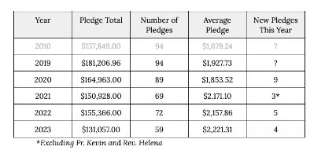

- 11 individuals or families who did pledge the last four years haven’t pledged yet for 2023. 5 more pledges – up to $138K. 7 or 8 who pledged over the last 4 years. Hoping for 70 pledges. Have 4 new pledges
- Two alternatives for child care during the 10:15 service were discussed:
  - Paid child care provider with a volunteer assistant. Volunteer would be at least 16 and could be filled by Confirmation candidates needing service hours. Children would be brought up after the Liturgy of the Word.
  - Tech team to place laptop in the library that is tuned to the service on the Facebook. Families with young children can still participate in the service while giving their children a break in a safe place.

Committee Updates: none

Celebrations:
- Angelo Troiano father is 65
- Rev. Helena’s father in law is 80
- Marriage Equality Bill signed
Closing Prayer – Rev. Helena
Minutes Submitted by:
Neil Walker

Appendix A –By-law Review
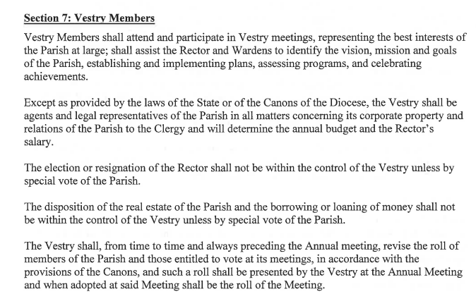

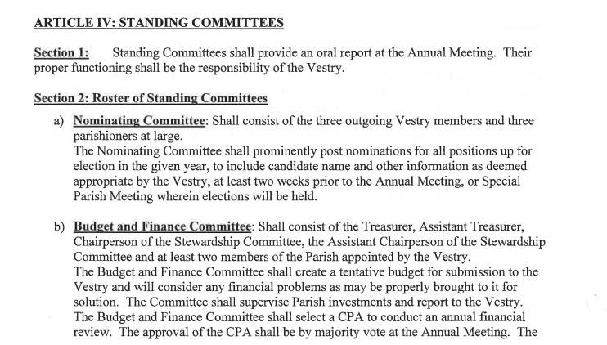
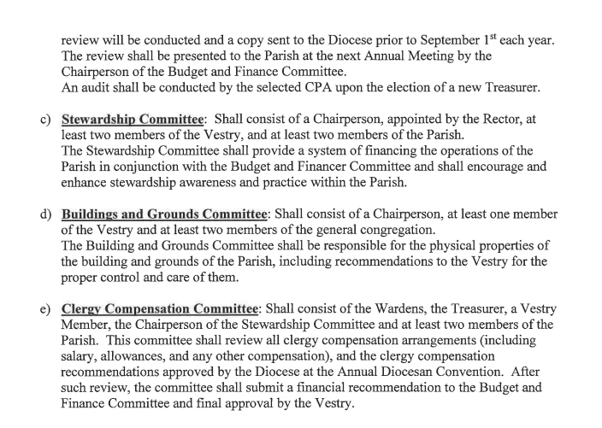
Appendix B – Proposed 2023 budget
 | Approved | YTD |  | Proposed
 | 2022 Budget | AS OF |  | $2,023.00
 | Total | 10/31/2022 | Difference | Budget
Revenue
4100 Pledges
4101 C/Y Pledge Receipts | $140,000.00 | $103,633.03 | $36,366.97 | $138,000.00
4102 Prior Year Pledge Receipts | $0.00 | $300.00 | ($300.00)
4104 Non Reimbursed Processing Fees | ($200.00) | ($91.77) | ($108.23) | -$200.00
Total 4100 Pledges | $139,800.00 | $103,841.26 | $35,958.74 | $137,800.00
4200 Plate Offering | $8,000.00 | $9,713.33 | ($1,713.33) | $10,000.00
4300 Donations in Lieu of Rent
4301 AA/NA etc. | $2,000.00 | $1,100.00 | $900.00 | $1,500.00
4302 Other | $500.00 | $0.00 | $500.00
Total 4300 Donations in Lieu of Rent | $2,500.00 | $1,100.00 | $1,400.00 | $1,500.00
4400 Seasonal Offerings
4401 Advent/Christmas | $1,300.00 | $50.00 | $1,250.00 | $500.00
4402 Lent/Easter | $700.00 | $460.00 | $240.00 | $500.00
Total 4400 Seasonal Offerings | $2,000.00 | $510.00 | $1,490.00 | $1,000.00
4500 Special Receipts/Other
4501 Altar Flowers | $750.00 | $675.00 | $75.00 | $800.00
4502 Fundraising | $2,000.00 |  | $2,000.00
4502-c Amazon Smile | $60.00 | $63.75 | ($3.75) | $75.00
Total 4502 Fundraising | $2,060.00 | $63.75 | $1,996.25 | $75.00
Total 4500 Special Receipts/Other | $2,810.00 | $738.75 | $2,071.25 | $875.00
4600 Investment Income
4601 D&B General Funds #4587/4626 | $4,500.00 | $6,281.61 | ($1,781.61) | $7,500.00
4602 D&B Housing Fund #4584 | $5,800.00 | $5,580.95 | $219.05 | $7,000.00
4603 Income Distr-E Brooks Fund | $24,000.00 | $20,927.25 | $3,072.75 | $25,000.00
Total 4600 Investment Income | $34,300.00 | $32,789.81 | $1,510.19 | $39,500.00
Total Revenue | $189,410.00 | $148,693.15 | $40,716.85 | $190,675.00
Gross Profit | $189,410.00 | $148,693.15 | $40,716.85 | $190,675.00
Expenditures
5100 Salary/Compensation
5101 Salaries
5102 Rector's Salary | $24,594.00 | $19,910.42 | $4,683.58 | $26,789.50
5103 Supply Clergy | $0.00 | $500.00 | ($500.00) | $3,000.00
5104 Christian Ed Director Wages | $4,500.00 | $198.32 | $4,301.68
5105 Organist Salary | $13,580.00 | $10,581.48 | $2,998.52 | $14,544.18
5107 Office Assistant | $10,732.80 | $7,833.46 | $2,899.34 | $17,680.00
5110 Sexton Wages | $5,000.00 | $2,401.76 | $2,598.24 | $4,500.00
Total 5101 Salaries | $58,406.80 | $41,425.44 | $16,981.36 | $66,513.68
5121 Pension
5122 Rector Pension | $10,900.00 | $6,681.40 | $4,218.60 | $11,992.90
Total 5121 Pension | $10,900.00 | $6,681.40 | $4,218.60 | $11,992.90
5131 Health & Lite Insurance
5132 Rector Health/Life Insurance | $16,980.75 | $13,707.75 | $3,273.00 | $18,720.19
Total 5131 Health & Lite Insurance | $16,980.75 | $13,707.75 | $3,273.00 | $18,720.19
5140 Housing Allowance
5141 Rector's Housing Allowance | $15,000.00 | $12,504.09 | $2,495.91 | $15,000.00
Total 5140 Housing Allowance | $15,000.00 | $12,504.09 | $2,495.91 | $15,000.00
5151 Social Security/Medicare
5152 Rector's Soc Sec Allowance | $6,821.70 | $3,636.28 | $3,185.42 | $6,117.53
5153 Employer Contribution | $2,818.00 | $1,594.82 | $1,223.18 | $2,550.00
5154 Additional CT Paid Leave Payment |  |  |  | $75.00
Total 5151 Social Security/Medicare | $9,639.70 | $5,231.10 | $4,408.60 | $8,667.53
5160 Study Expenses
5161 Rector Study Expense | $1,850.00 | $1,180.08 | $669.92 | $1,850.00
Total 5160 Study Expenses | $1,850.00 | $1,180.08 | $669.92 | $1,850.00
5170 Professional Expenses
5171 Rector Professional Expenses | $1,500.00 | $1,367.25 | $132.75 | $1,500.00
Total 5170 Professional Expenses | $1,500.00 | $1,367.25 | $132.75 | $1,500.00
5181 Payroll Expenses | $1,500.00 | $1,109.99 | $390.01 | $1,500.00
Total 5100 Salary/Compensation | $115,777.25 | $83,207.10 | $32,570.15 | $125,744.30
5200 Worship
5201 Altar Flower Expense | $700.00 | $231.69 | $468.31 | $500.00
5211 Altar Supplies | $0.00 | $10.50 | ($10.50) | $250.00
5212 Altar Bread/Wine | $100.00 | $141.30 | ($41.30) | $200.00
5213 Candles | $100.00 | $0.00 | $100.00 | $100.00
5215 Other | $100.00 | $83.08 | $16.92 | $100.00
Total 5211 Altar Supplies | $300.00 | $234.88 | $65.12 | $650.00
5221 Music Expense | $2,500.00 | $1,615.00 | $885.00 | $2,600.00
5222 Bell Choir | $200.00 | $76.56 | $123.44 | $1,500.00
Total 5221 Music Expense | $2,700.00 | $1,691.56 | $1,008.44 | $4,100.00
5231 Worship Technology | $0.00 | $447.53 | ($447.53) | $250.00
Total 5200 Worship | $3,700.00 | $2,605.66 | $1,094.34 | $5,500.00
5300 Christian Ed
5301 Children's Ed | $1,435.00 | $539.80 | $895.20 | $1,000.00
5311 Youth Ministry | $1,479.00 | $352.62 | $1,126.38 | $1,500.00
5321 Adult Ed | $200.00 | $0.00 | $200.00 | $200.00
5331 J2A -Pilgramage | $1,153.92 | $750.00 | $403.92 | $1,000.00
Total 5300 Christian Ed | $4,267.92 | $1,642.42 | $2,625.50 | $3,700.00
5400 Outreach
5401 Diocese Pledge | $17,792.00 | $14,826.70 | $2,965.30 | $18,931.70
5411 Mission & Outreach | $250.00 | $506.00 | ($256.00) | $550.00
5412 Parish Care | $200.00 | $90.25 | $109.75 | $300.00
5413 Welcome Committee | $150.00 | $0.00 | $150.00 | $400.00
5421 Rector's Discretionary |  |  |  | $1,000.00
Total 5400 Outreach | $18,392.00 | $15,422.95 | $2,969.05 | $21,181.70
5500 Office Expenses
5501 Postage | $300.00 | $125.50 | $174.50 | $300.00
5511 Governance | $750.00 | $184.50 | $565.50 | $250.00
5513 Telephone | $4,250.00 | $4,677.48 | ($427.48) | $2,500.00
5521 Software | $2,000.00 | $717.44 | $1,282.56 | $1,250.00
5531 Communications | $200.00 | $160.00 | $40.00 | $250.00
5541 Printing | $0.00 | $265.52 | ($265.52) | $500.00
5551 Copier | $2,600.00 | $2,235.64 | $364.36 | $2,600.00
5561 Supplies
5563 Supplies-Other | $600.00 | $344.59 | $255.41 | $500.00
Total 5561 Supplies | $600.00 | $344.59 | $255.41 | $500.00
5571 CPA Review | $4,850.00 | $3,500.00 | $1,350.00 | $1,800.00
Total 5500 Office Expenses | $15,550.00 | $12,210.67 | $3,339.33 | $9,950.00
5600 Buildings & Property Expenses
5601 Property Insurance | $7,400.00 | $7,547.92 | ($147.92) | $9,750.00
5611 Maintenance & Repairs | $3,000.00 | $14,572.48 | ($11,572.48) | $4,400.00
5621 Utilities
5622 Electricity | $5,000.00 | $3,259.89 | $1,740.11 | $7,250.00
5623 Gas | $8,500.00 | $7,831.63 | $668.37 | $11,250.00
5624 Water/Sewer | $2,000.00 | $1,012.25 | $987.75 | $1,500.00
Total 5621 Utilities | $15,500.00 | $12,103.77 | $3,396.23 | $20,000.00
5631 Contract Services
5632 Fire Protection System Service | $1,200.00 | $1,853.00 | ($653.00) | $1,200.00
5633 Pest Control | $1,000.00 | $318.00 | $682.00 | $500.00
5634 Floor Maintenance Service | $600.00 | $0.00 | $600.00 | $1,350.00
5635 Heating System | $650.00 | $1,235.00 | ($585.00) | $1,000.00
5636 Snow Removal Service | $5,374.00 | $4,030.50 | $1,343.50 | $7,000.00
5637 Trash Removal | $720.00 | $631.30 | $88.70 | $800.00
Total 5631 Contract Services | $9,544.00 | $8,067.80 | $1,476.20 | $11,850.00
5641 Sexton's Supplies | $750.00 | $162.57 | $587.43 | $500.00
Total 5600 Buildings & Property Expenses | $36,194.00 | $42,454.54 | ($6,260.54) | $46,500.00
Total Expenditures | $193,881.17 | $157,543.34 | $36,337.83 | $212,576.00
Net Operating Revenue | ($4,471.17) | ($8,850.19) | $4,379.02 | -$21,901.00
Net Revenue | ($4,471.17) | ($8,850.19) | $4,379.02 | -$21,901.00

