St. Paul’s Episcopal Church
145 Main Street
Southington, CT 06489

VESTRY MEETING
Minutes from November 11, 2022

Voting Members Present:
Mary Palinkos, Jennifer Hinckley, Rev. Helena Martin, Chris Marquis, Geoff Herman, Cory Cyr, Angelo Troiano, Mike Richardson, Amy Cook, Amanda Barnes Sisson, Neil Walker
Voting Members Absent:
Leigh Sillner
Visitor Present: Kate Palinkos, Palinkos, Meredith Bandish, Joe Franco, Naomi Cunningham (St. Lukes, Darien)
Opening Spiritual Exercise: Rev. Helena
Readings from Randle on Technical versus Adaptive Change as applied to Episcopal churches
Visitors Forum:
- Meredith Bandish and Kate Palinkos on the 2023 Mission Trip. See Appendix A
- Naomi Cunningham (St. Luke’s Darien) and Rev. Helena on Young Adults in the Episcopal Church of Connecticut. See Appendix B
Old Business: none
October Minutes:
Due to the incorrect minutes being submitted for review, the vote for approval was delayed until December, 2022
Treasurer Report: Angelo Troiano
See Appendix C for the October 2022 Operating Income and Expense Statement.
- Continuing to move financial documents to the Saint Paul DropBox.
- Turned in the Agreed Upon Procedures to Massucci & Associates. Awaiting invoice
- 2023 Budget Committee meeting scheduled for Friday November 18th @ 6:30pm.
- Working on financials for the 2023 mission trip, so we can figure out what the church may cover, what parents will cover, and what fundraising will be necessary.
- New deposit slip books ordered, they should be in Monday November 7th.
- Need more QuickBooks checks. Will be submitting the order soon.
- Reallocated some payments in regards to Rev. Helena that could have fallen under either study expense or professional expense to better even out the accounts, as study expense was over budget and professional expense was under budget.
- new assistant sexton Jesse Nealon has been entered into payroll, and has received his first check
- Oct 2022 Monthly Budget vs. Actual Net Revenue total of ($130,356.02) we had a loss of $132,623.46 in value of invested funds. Without that loss we had an October net revenue total of $2,267.44.
- There were $205.00 in donations to the Bishop’s Fund in honor of Jenn Handi.
The vote for approval of the October Treasurer’s report was delay in order to answer the following questions:
Q1: In the Budget V. Actual spreadsheet, why are there duplicate Payroll Expenses items under expenses? One has budget item 5181 with an expense of $1226.14, the other two are unnumbered and have $0.00 in expenses.
A1: The two non-numbered items are not used and it is not clear why they are listed in the spreadsheet. The payroll expense listed in budget item 5181 is correct.

Q2: In the Cash Analysis spreadsheet of the Comparative Balance Sheet workbook, why is the balance for Youth Education -$892.42.
A2: The expenses for the following budget items were mistakenly entered into the Youth Education line in Cash Analysis:

Budget Item | Description | Expense
5301 | Children’s Ed | $539.80
5311 | Youth Ministry | $352.62
Total |  | $892.42

The actual balance is $163.50 which is what it was at the end of last year.

Need a vote from Vestry in regards to the $163.50 as it is listed as restricted for Youth Education. Recommend removing it from the cash analysis page as it is money already in our account and we already have Christian Education and Youth Ministry line items.

Two potential alternatives to the following budget items:

5301 Children's Education
5311 Youth Ministry
5331 J2A - Pilgrimage

Alternative1:

5301 Children's Education as anything up to Rite 13
5311 Youth Ministry as Rite 13
5331 J2A – Pilgrimage

Alternative2:

5301 Children's Education is anything to do with Christian Formation
5311 Youth Ministry would be like the mission trip, anything non-Christian Formation for the youth
5331 J2A – Pilgrimage

Need a vote from Vestry on how to reclassify budget items 5301 and 5311.

Clergy Updates: Rev. Helena
- Rev. Helena is pregnant, due in May! Her health is being challenged by the pregnancy. The Vestry prays for Rev. Helena and her new baby and for patience and strength of her husband John
- Current estimates are that Rev. Helena will receive 12 weeks of disability leave through Church Pension Group (CPG). During that time, CPG covers 70% of Rev. Helena’s salary with St. Paul’s responsible for the other 30%. Clergy coverage will be discussed at a later time. To complete the summer, Rev. Helena will use 4 weeks of vacation after short term disability ends.
- Olivia Zenobi has resigned as Office Administrator. She loved working at St. Paul’s, but her church offered her a full-time job in the career she’s working toward.
- On Sunday, November 6, a small group from St. Mark’s New Britain visited the 10:15am service. St. Mark’s is closing. They are evaluating which nearby church they will merge with. They were excited about our children’s ministry and loved being in the congregation for the pregnancy announcement! Hope to continue the dialog.
- Jenn Handi and Rev. Helena began teaching a youth confirmation class for six high school seniors on Sunday, November 6. Vestry members are encouraged to volunteer as sponsors. Sponsorship entails praying for the confirmation candidates and meeting with them casually 1-2 times this year to talk about faith – yours and theirs.
- The vestry decided to make masks optional in the parish hall. Masks are still be required in hallways, classrooms, bathrooms, sanctuary and during large gatherings in the parish hall.
- Rev. Helena asked the vestry to consider the following modifications to the service:

  - Bring back the communion rail, but with only one household kneeing at a time
  - Optional Eucharistic wine in reusable cups. Not drinking from the chalice

The Vestry agreed and Rev. Helena will work with the Altar Guild on implementation of Eucharistic wine
- Geoff Herman made a motion to support a youth mission trip in 2023. Mary Palinkos seconded. Details on trip cost are forthcoming. At a minimum St. Paul’s will pay for rented vehicles and all expenses incurred by the chaperones. Youth expenses will be paid by each family. The motion passed unanimously.
- Angelo Troiano made a motion to allow the J2A to have a St. Paul’s Greeting Card fundraiser. Cost will be 12 cards for $10. Geoff Herman seconded. The motion passed unanimously.

Committee Updates:
Stewardship – Mary Palinkos
- Stewardship Committee is comprised of Mary Palinkos Kathy Lafland and Darrel Kenney
- Stewardship Letters out by November 12.
Closing Prayer – Rev. Helena
Minutes Submitted by:
Neil Walker

Appendix A – St. Paul’s J2A Mission Trip 2023

Presented by Meredith Bandish and Kate Palinkos

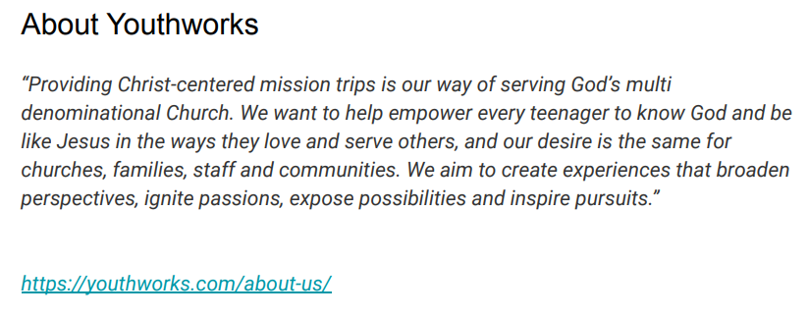
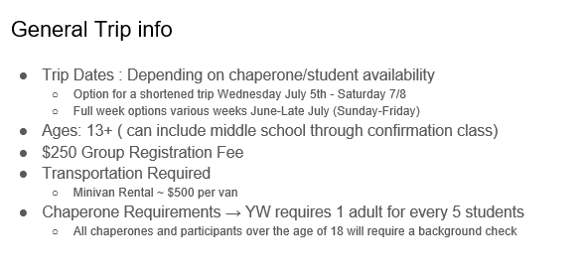
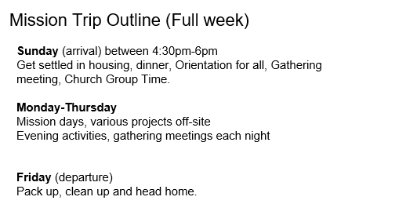
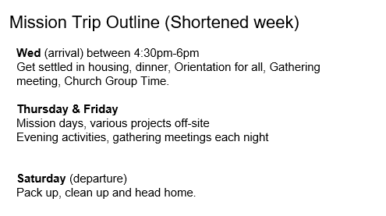
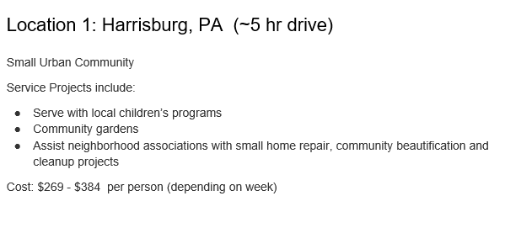
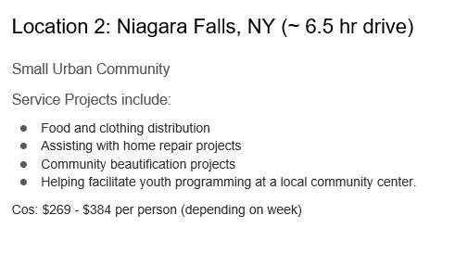
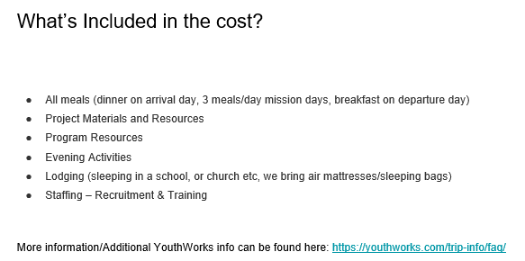

Appendix B – Young Adults (aged 18-39) in the Episcopal Church of Connecticut
Presented by Naomi Cunningham and Rev. Helena.
See “A New Vision for Young Adults and God’s Mission”, Evangelism of and by Young Adults: A Report to the 237th Annual Convention of the Episcopal Church in Connecticut:
https://www.episcopalct.org/wp-content/uploads/2022/06/ECCT-Young-Adult-Task-Force-Report-2021.pdf
This report doesn’t make recommendations at the parish level
- The Episcopal Church in Connecticut is not good at inviting youth ministry and doesn’t spend money on young adults
- Average age of parishioners in the Episcopal Church of Connecticut is 69. Oldest denomination in Connecticut. Youngest groups are atheists.
- State and church are shrinking. No one at the diocese working on young adults but Bishop Jeff Mello is committed to young adults
- St. Paul’s doesn’t have access young adults at a local college
- Some highlights of the Southington’s demographics 50-59 and 0-19 (see https://www.niche.com/places-to-live/southington-hartford-ct/residents/)
17% of population between 18 and 39
30% of population between 45-64
21% of population 65 and over
Roman Catholic – 32%
Episcopal – 1.3%
White – 89%

- Myth or fact of 20-30 year olds:

- Young adults get turned off by hypocrisy in church. True
- Young adults are leaving the church because they don’t believe in God. Myth
- Young adults are looking for the type of community like they can find in church. True Community at church has unique attributes. Especially if you grew up in church you won’t find that type of community anywhere else
- Young adults are more likely to participate if they are personally invited. True, especially If they have someone who can experience church with them
- Young adults will not give to the church. Myth. Can’t give much financially. Will give money to specific causes or something that they have a passion for. Less likely to give out of obligation.
- Young adults are people 15-20. Myth. 18-39
- Young adults report that they rarely experience a warm or knowledgeable welcome when trying out a new church. Fact.
- Young adults want the Episcopal Church to grapple with its identity as a white privileged church. Fact
- Many young adults are unaware of a vibrant alternative to parishes with empty pews or evangelical or progressive Christianity. Fact.
- Church devotes resources to young adults. Myth
- Main thing young adults want from church experience is contemporary music. Myth
- Young adults care about social justice and want to talk about it in a church context. Fact
- Young adults do not want leadership roles in the church. Myth
- Young adults do not like traditional church architecture. Myth
- Young adults express a desire of deeper spiritual formation. Fact

- What is St. Paul’s doing:

- LBGTQ+ flag
- Rise Against Hunger
- Racial Justice
- Youth member on the vestry – trying to get young adults in a leadership role. We are embracing young adults in leadership. As we do it more and more, will hopefully have more. Structural changes like to have young adults in leadership roles. Not necessarily here on Sundays.
- Good youth program – needed for young adult program, 6) College adoptee program – sense of home.
Some recommendations:
- Welcoming – don’t want to pounce on new people. If you come with your children, people will notice. If you come alone, you may not get noticed.
- Figure out how to (re)engage young adults. A lot of the young adults who are no longer attending were just dropping off their kids for Sunday school.
- Secret – just do good church in general. People are seeking god and community. Intentionally get better at being church and young adults will come.
- Trying new things, for example Christian rock band or more contemporary music, is not effective at attracting young adults
- Guidance from Bishop Jeff Mello: Welcoming is being available to be changed by newcomers. How can we create and recreate

      - Next right thing for St. Paul’s to do:
- Invite back the families that left
- Cultivate curiosity and be venerable and open to change.
- Invite Welcome Connect program (https://www.invitewelcomeconnect.com/)
- Identify young adults already in your parish and figure out how we can serve them. For example: First Congregational has a young adult meeting every Tuesday night for 20’s and 30’s.
- Figure out why you are you inviting young adults

Appendix C – October Operating Income and Expenses
 | Oct-22 | Oct 2021 (PY)
Revenue
4100 Pledges
4101 C/Y Pledge Receipts | $10,582.55 | $20,978.00
4104 Non Reimbursed Processing Fees | ($15.43) | ($11.92)
Total 4100 Pledges | $10,567.12 | $20,966.08
4200 Plate Offering | $1,023.83 | $1,290.00
4300 Donations in Lieu of Rent
4301 AA/NA etc. | $150.00 | $190.00
Total 4300 Donations in Lieu of Rent | $150.00 | $190.00
4500 Special Receipts/Other
4501 Altar Flowers |  | $40.00
4504 Diocesan Grants |  | $1,522.50
4506 Restricted Gifts for Processing Fees | $60.27 | $82.40
4506-a Processing Fees Deducted | ($60.27) | ($82.40)
Total 4506 Restricted Gifts for Processing Fees | $0.00 | $0.00
Total 4500 Special Receipts/Other | $0.00 | $1,562.50
4600 Investment Income
4601 D&B General Funds #4587/4626 | $753.83 | $957.61
4602 D&B Housing Fund #4584 | $887.62 | $1,127.57
Total 4600 Investment Income | $1,641.45 | $2,085.18
Total Revenue | $13,382.40 | $26,093.76
Gross Profit | $13,382.40 | $26,093.76
Expenditures
5100 Salary/Compensation
5101 Salaries
5102 Rector's Salary | $1,886.82 | $1,789.08
5102A Missional Curate |  | $0.00
5103 Supply Clergy | $250.00
5104 Christian Ed Director Wages |  | $306.00
5105 Organist Salary | $1,007.76 | $1,007.76
5107 Office Assistant | $824.16 | $315.00
5110 Sexton Wages | $253.71 | $229.50
Total 5101 Salaries | $4,222.45 | $3,647.34
5121 Pension
5122 Rector Pension | $503.95 | $1,528.14
5124 Pension-Curate |  | $134.64
Total 5121 Pension | $503.95 | $1,662.78
5131 Health & Lite Insurance
5132 Rector Health/Life Insurance | $30.00 | $30.00
Total 5131 Health & Lite Insurance | $30.00 | $30.00
5140 Housing Allowance
5141 Rector's Housing Allowance | $1,150.52 | $1,150.68
Total 5140 Housing Allowance | $1,150.52 | $1,150.68
5151 Social Security/Medicare
5152 Rector's Soc Sec Allowance | $307.08 | $297.20
5153 Employer Contribution | $159.56 | $142.19
Total 5151 Social Security/Medicare | $466.64 | $439.39
5170 Professional Expenses
5171 Rector Professional Expenses |  | $77.00
5172 Missional Curate Professional Expense |  | $118.88
Total 5170 Professional Expenses | $0.00 | $195.88
5181 Payroll Expenses | $116.15 | $116.15
Total 5100 Salary/Compensation | $6,489.71 | $7,242.22
5400 Outreach
5401 Diocese Pledge | $1,482.67 | $1,584.00
5412 Parish Care | $90.25
Total 5400 Outreach | $1,572.92 | $1,584.00
5500 Office Expenses
5501 Postage | $120.00 | $116.00
5511 Governance |  | $95.00
5513 Telephone |  | $317.39
5521 Software | $91.85 | $169.09
5531 Communications | $20.00
5541 Printing | $135.10
5551 Copier | $813.34 | $292.27
5561 Supplies
5563 Supplies-Other | $29.77
Total 5561 Supplies | $29.77 | $0.00
Total 5500 Office Expenses | $1,210.06 | $989.75
5600 Buildings & Property Expenses
5601 Property Insurance | $802.19 | $590.86
5611 Maintenance & Repairs |  | $240.05
5621 Utilities
5622 Electricity | $415.08 | $717.89
5623 Gas | $402.36
Total 5621 Utilities | $817.44 | $717.89
5631 Contract Services
5632 Fire Protection System Service | $439.00 | $350.00
5637 Trash Removal | $65.80 | $168.04
Total 5631 Contract Services | $504.80 | $518.04
Total 5600 Buildings & Property Expenses | $2,124.43 | $2,066.84
Payroll Expenses
Wages |  | $0.00
Total Payroll Expenses | $0.00 | $0.00
Total Expenditures | $11,397.12 | $11,882.81
Net Operating Revenue | $1,985.28 | $14,210.95
Saturday, Nov 05, 2022 07:19:01 PM GMT-7 - Cash Basis

