St. Paul’s Episcopal Church

145 Main Street

Southington, CT 06489

**VESTRY MEETING**

Minutes from December 10, 2024

**Voting Members Present:**

Mary Palinkos, Geoff Herman, Chris Marquis, Bill Shea, Judy Ryan, Neil Walker, Carol Langston, Joseph Franco, Hayden Olsen

**Voting Members Absent:** Angelo Trioano

**Non-Voting Members:** Martin Morrissey

**Spiritual Gathering:** Mary Palinkos

Prince of Peace, in a world filled with turmoil, grant us the tranquility that only your peace can bring. Help us to be instruments of reconciliation and harmony in our relationships and communities. Amen

The vestry wrote thank you notes for those who pledged in 2025 to St. Paul’s for 30 minutes.

**Visitors Forum:** none

**Old Business**: Mary Palinkos and Geoff Herman

* Rector Search update:
* See Appendix B – St. Paul’s Parish Profile submitted to ECCT for Rector Search
* ECCT starting the process of looking for potential candidates. ECCT will also provide support during mock interviews with the vestry
* More Connecticut parishes are looking for rectors instead of a priest in charge after the diocese changed the rules based on feedback from the parishes in transition. Rectors have tenure and it is a more desirable role than priest in charge. Two parishes in Connecticut are looking for full time rectors, most are looking for ¼ or ½ time rectors or priests in charge
* AED training will be provided in 2025
* Safe Church: Bill Shea, Marty Morrisey and Hayden Olsen in the process of completing their training
* Parking lot money
  + Laptop plus wireless speakers ordered
  + Chairs and tables will be ordered in 2025
  + Donation to Rise Against Hunger will be made prior to March 1, 2025
* Annual Meeting: January 19, 2025

**Treasurer Report**: Marty Morrissey

* 2025 budget – see Appendix A St. Paul’s 2025 Budget
  + Projected $6K deficit, mitigated by $22K surplus in 2024. Deficit could also be covered by withdrawing money from St. Paul’s investments
  + Strategic planning financial planning needed
  + Total revenue $178K in 2025, 20% less than 5 years ago
  + The vestry discussed the lack of funding for the Christian Ed director in the budget. Neil Walker and Hayden Olsen to talk to other churches about what they are doing to maintain their youth programs
  + Mary Palinkos made a motion to approve the 2025 budget. Geoff Herman seconded. The **motion passed** 8 to 1.

**November 2024 minutes:**

Joe Franco made a motion to accept the amended September minutes. Mary Palinkos seconded. The **motion passed** unanimously.

**Committee Reports:**

* Nominating Committee
  + Committee members: Chris Marquis, Judy Ryan, MaryAnn Sobeleski and Trish Leonard
  + Slate of candidates for election during the 2025 Annual Meeting as of December 10, 2024:
    - Senior warden: Mary Palinkos
    - Junior warden: Geoff Herman
    - Treasurer: Marty Morrissey
    - Assistant Treasurer: unfilled
    - Clerk: Neil Walker
    - Vestry 2026: Joe Franco, Carol Langston
    - Vestry 2027: Hayden Olsen and Bill Shea
    - Vestry 2028: Judy Ryan
    - Conveniton Delegates: Mary Muller and Quinton Johansen
    - Alternative Convention Delegate: Chris Marquis
  + Unfilled positions: two convention delegates, Assistant Treasurer and 1 vestry for 2028
* Building and Grounds:
  + Roof:
    - Almost completed. Still need to get inside repairs done
    - Cross on steeple came down as part of the reroofing job. Needs repair and will be reinstalled at a later date
    - Received second check from insurance
  + Furnace:
    - George Touma submitted two quotes to repair the furnace. The furnace unreliably heats the sanctuary on Sunday mornings (see Appendix C for the two quotes). During an online vote conducted on January 2, 2025, Joe Franco motioned to have Douglas Mechanical Services replace to replace the furnace electronic controller and sensors for the quoted price of $3477.50. Bill Shea seconded. The **motion passed** unanimously.
    - The furnace is over 32 years old and nearing the end of its useful life and should be considered in the above mentioned strategic plan.
  + Cleaning in the sanctuary: Judy Ryan made a motion to have the carpeting in the sanctuary and altar cleaned, plus the upholstered chairs, for $700. Contractor is Janitize, the same company cleaning our sanctuary and parish hall every week. Chris Marquis seconded. The **motion passed** unanimously.
* Youth Formation – Bill Shea
* Need to pick some dates for youth formation going forward. Might do Godly play during some of the sessions.
* Outreach – Chris Marquis
* Operation stay warm – 5 volunteers from St. Paul’s staffed the Operation Stay Warm Boutique at Lincoln Terrace Apartments for distributing winter coats and accessories to the residents. Over 600 coats were given out.
* LISA Inc. gift cards and bags for 40 individuals were collected
* Gifts for families in need as identified by Southington Social Services are still being collected
* Parish Care – Carol Langston
* Cookie swap December 15. Will be taking cookies to home bound parishioners
* Meals for the Trioano’s
* Stewardship:
* 46 pledging units, out of 115 pledge mailed letters. $125K pledged so far. Looking for a few more pledges. Some former parishioners are still pledging
* St. Paul’s typically collects less that what is pledged
* The value of what each member pledges is confidential
* At least one parishioner expressed anger at having the names of the those who pledged listed in the 12/1/24 St. Paul’s announcements email
* Welcoming – Hayden Olsen
* Wear your name tag
* Worship
* Christmas pageant on 12/22. Multi-generational. Trish Leonard and Doreen Bottone are coordinating
* Looking for supply clergy to fill two open Sundays in January
* Christmas Services – Christmas Eve – 5:30pm with Canon Tim Hodapp, Christmas Day – 9am with Salin Low

**Other Business:** none

Celebrations:

* Hayden Olsen and Crista are engaged. They want to get married at St. Paul’s, date is TBD. Rev. Mo will be officiating.
* Emily Palinkos is receiving her doctorate as a nurse practitioner this month.

**Closing Prayer:** Carol Langston

From Saint Augustine’s Prayer Book by Derek Olsen and David Cobb

O Lord Jesus Christ, as you humbled yourself to be born among us and laid in a manger, bring us with the shepherds and wise men to kneel in awe and joyful thanksgiving and to follow the steps of your blessed life; that rejoicing now in your peace, we may come at the last to eternal glory in your presence, where the angels ever sing your praises. Amen

**December Closing Prayer:** Carol Langston

**From** Saint Augustine’s Prayer Book by David Cobb and Derek Olsen

O Lord Jesus Christ, as you humbled yourself to be born among us and laid in a manger, bring us with the shepherds and wise men to kneel in awe and joyful thanksgiving and to follow the steps of your blessed life; that rejoicing now in your peace, we may come at the last to eternal glory in your presence, where he angels ever sing your praises. Amen

Minutes Submitted by:

Neil Walker

# Appendix A St. Paul’s 2025 Budget

|  |  |  |  |  |  |  |  |
| --- | --- | --- | --- | --- | --- | --- | --- |
| **Removed from 2024 to 2025 budget** |  |  |  |  |  |  |  |
| **Non-budgeted lines** |  |  |  |  |  |  |  |
|  | **YTD Actual 10/31/24** | **Average per Month** | **Estimate for Remainder of 2024** | **2024 Estimated Total** | **2024 Budgeted Amount** | **Difference** | **2025 Proposed Budget** |
| **Revenue** |  |  |  |  |  |  |  |
| **4100 Pledges** |  |  |  |  |  |  |  |
| **4101 C/Y Pledge Receipts** | $99,160.55 | $9,916.06 | $19,832.11 | **$118,992.66** | $144,670.00 | $25,677.34 | $125,000.00 |
| **4102 Prior Year Pledge Receipts** | $12,343.00 |  |  | **$12,343.00** |  | $(12,343.00) |  |
| **4104 Non Reimbursed Processing Fees** | $(6.40) | $(0.64) | $(1.28) | **$(7.68)** | $(150.00) | $(142.32) | $(25.00) |
| **Total 4100 Pledges** | **$111,497.15** | **$9,915.42** | **$19,830.83** | **$131,327.98** | **$144,520.00** | **$13,192.02** | **$124,975.00** |
| **4200 Plate Offering** | **$11,441.70** | **$1,144.17** | **$2,288.34** | **$13,730.04** | **$10,000.00** | **$(3,730.04)** | **$10,000.00** |
| **4300 Donations in Lieu of Rent** |  |  |  |  |  |  |  |
| **4301 AA/NA etc.** | $1,690.00 | $169.00 | $338.00 | **$2,028.00** | $2,000.00 | $(28.00) | $2,000.00 |
| **4302 Other** | $250.00 | $25.00 | $50.00 | **$300.00** |  | $(300.00) |  |
| **Total 4300 Donations in Lieu of Rent** | **$1,940.00** | **$194.00** | **$388.00** | **$2,328.00** | **$2,000.00** | **$(328.00)** | **$2,000.00** |
| **4400 Seasonal Offerings** |  |  |  |  |  |  |  |
| **4401 Advent/Christmas** |  |  | $500.00 |  | $500.00 | $500.00 | $500.00 |
| **4402 Lent/Easter** | $969.00 |  |  | **$969.00** | $500.00 | $(469.00) | $500.00 |
| **Total 4400 Seasonal Offerings** | **$969.00** | **$-** | **$500.00** | **$969.00** | **$1,000.00** | **$31.00** | **$1,000.00** |
| **4500 Special Receipts/Other** |  |  |  |  |  |  |  |
| **4501 Altar Flowers** | $555.00 | $55.50 | $111.00 | **$666.00** | $1,000.00 | $334.00 | $750.00 |
| **4504 Diocesan Grants** | $1,395.00 | $139.50 | $279.00 | **$1,674.00** |  | $(1,674.00) |  |
| **4506 Restricted Gifts for Processing Fees** | $375.73 | $37.57 | $75.15 | **$450.88** |  | $(450.88) |  |
| **4506-a Processing Fees Deducted** | $(382.23) | $(38.22) | $(76.45) | **$(458.68)** |  | $458.68 |  |
| **Total 4506 Restricted Gifts for Processing Fees** |  |  |  |  |  |  |  |
| **Total 4500 Special Receipts/Other** | **$1,388.50** | **$138.85** | **$277.70** | **$1,666.20** | **$-** | **$(1,666.20)** | $- |
| **4600 Investment Income** |  |  |  |  |  |  |  |
| **4601 D&B General Funds #4587/4626** | $7,112.45 | $711.25 | $1,422.49 | **$8,534.94** | $7,500.00 | $(1,034.94) | $7,500.00 |
| **4602 D&B Housing Fund #4584** | $8,374.80 | $837.48 | $1,674.96 | **$10,049.76** | $7,000.00 | $(3,049.76) | $7,000.00 |
| **4603 Income Distr-E Brooks Fund** | $18,359.00 | $1,835.90 | $3,671.80 | **$22,030.80** | $25,000.00 | $2,969.20 | $25,000.00 |
| **Total 4600 Investment Income** | **$33,846.25** | **$3,384.63** | **$6,769.25** | **$40,615.50** | **$39,500.00** | **$(1,115.50)** | **$39,500.00** |
| **Total Revenue** | **$161,637.60** | **$14,832.56** | **$30,165.12** | **$191,302.72** | **$198,020.00** | **$6,717.28** | **$178,225.00** |
| **Gross Profit** |  |  |  |  |  |  |  |
| **Expenditures** |  |  |  |  |  |  |  |
| **5100 Salary/Compensation** |  |  |  |  |  |  |  |
| **5101 Salaries** |  |  |  |  |  |  |  |
| **5102 Rector's Salary** | $14,653.74 |  |  | **$14,653.74** | $29,923.50 | $15,269.76 | $15,000.00 |
| **5103 Supply Clergy** | $1,286.52 | $700.00 | $1,400.00 | **$2,686.52** | $1,000.00 | $(1,686.52) | $4,200.00 |
| **5104 Christian Ed Director Wages** |  |  |  |  | $35,000.00 | $35,000.00 |  |
| **5105 Organist Salary** | $12,687.66 | $1,268.77 | $2,537.53 | **$15,225.19** | $14,987.78 | $(237.41) | $15,602.28 |
| **5107 Office Assistant** | $6,373.20 | $637.32 | $1,274.64 | **$7,647.84** |  | $(7,647.84) | $15,922.80 |
| **5108 Bookkeeper** | $7,860.00 | $786.00 | $1,572.00 | **$9,432.00** | $10,000.00 | $568.00 | $10,000.00 |
| **Total 5101 Salaries** | **$42,861.12** | **$3,392.09** | **$6,784.17** | **$49,645.29** | **$90,911.28** | **$41,265.99** | **$60,725.08** |
| **5121 Pension** |  |  |  |  |  |  |  |
| **5122 Rector Pension** | $4,031.60 |  |  | **$4,031.60** | $13,770.62 | $9,739.02 | $6,885.31 |
| **Total 5121 Pension** | **$4,031.60** | **$-** | **$-** | **$4,031.60** | **$13,770.62** | **$9,739.02** | **$6,885.31** |
| **5131 Health & Life Insurance** |  |  |  |  |  |  |  |
| **5132 Rector Health/Life Insurance** | $14,355.20 |  |  | **$14,355.20** | $26,409.60 | $12,054.40 | $13,204.80 |
| **5133 Group Life/Disability** |  |  |  |  | $6,240.00 | $6,240.00 | $3,120.00 |
| **Total 5131 Health & Life Insurance** | **$14,355.20** | **$-** | **$-** | **$14,355.20** | **$32,649.60** | **$18,294.40** | **$16,324.80** |
| **5140 Housing Allowance** |  |  |  |  |  |  |  |
| **5141 Rector's Housing Allowance** | $9,119.83 |  |  | **$9,119.83** | $15,000.00 | $5,880.17 | $7,500.00 |
| **Total 5140 Housing Allowance** | **$9,119.83** | **$-** | **$-** | **$9,119.83** | **$15,000.00** | **$5,880.17** | **$7,500.00** |
| **5151 Social Security/Medicare** |  |  |  |  |  |  |  |
| **5152 Rector's Soc Sec Allowance** | $4,435.17 |  |  | **$4,435.17** | $7,024.34 | $2,589.17 | $3,512.17 |
| **5153 Employer Contribution** | $1,413.64 | $141.36 | $282.73 | **$1,696.37** | $2,900.00 | $1,203.63 | $2,000.00 |
| **5154 Additional CT Paid Leave Payment** |  |  |  |  | $100.00 | $100.00 | $50.00 |
| **Total 5151 Social Security/Medicare** | **$5,848.81** | **$141.36** | **$282.73** | **$6,131.54** | **$10,024.34** | **$3,892.80** | **$5,562.17** |
| **5160 Study Expenses** |  |  |  |  |  |  |  |
| **5161 Rector Study Expense** | $236.39 |  |  | **$236.39** | $1,850.00 | $1,613.61 |  |
| **Total 5160 Study Expenses** | **$236.39** | **$-** | **$-** | **$236.39** | **$1,850.00** | **$1,613.61** | $925.00 |
| **5170 Professional Expenses** | $236.39 | $- | $- | $236.39 | $1,850.00 | $1,613.61 | **$925.00** |
| **5171 Rector Professional Expenses** | $289.13 |  |  | **$289.13** | $1,500.00 | $1,210.87 | $750.00 |
| **Total 5170 Professional Expenses** | **$289.13** | **$-** | **$-** | **$289.13** | **$1,500.00** | **$1,210.87** | **$750.00** |
| **5181 Payroll Expenses** | $486.00 | $48.60 | $97.20 | **$583.20** | $1,500.00 | $916.80 | $600.00 |
| **5135 Workers Comp Ins** | $197.00 | $19.70 | $39.40 | **$236.40** |  | $(236.40) | $250.00 |
| **Total 5181 Payroll Expenses** | **$683.00** | **$68.30** | **$136.60** | **$819.60** | **$1,500.00** | **$680.40** | **$850.00** |
| **Total 5100 Salary/Compensation** | **$77,425.08** | **$3,601.75** | **$7,203.50** | **$84,628.58** | **$167,205.84** | **$82,577.26** | **$99,522.36** |
| **5200 Worship** |  |  |  |  |  |  |  |
| **5201 Altar Flower Expense** | $413.81 | $41.38 | $82.76 | **$496.57** | $500.00 | $3.43 | $500.00 |
| **5211 Altar Supplies** | $15.99 | $1.60 | $3.20 | **$19.19** |  | $(19.19) |  |
| **5212 Altar Bread/Wine** | $34.02 | $3.40 | $6.80 | **$40.82** | $350.00 | $309.18 | $150.00 |
| **5213 Candles** | $688.65 | $68.87 | $137.73 | **$826.38** | $250.00 | $(576.38) | $850.00 |
| **5215 Other** | $133.10 | $13.31 | $26.62 | **$159.72** |  | $(159.72) |  |
| **Total 5211 Altar Supplies** | **$1,152.47** | **$115.25** | **$230.49** | **$1,382.96** | **$1,100.00** | **$(282.96)** | **$1,500.00** |
| **5221 Music Expense** | $2,179.06 |  |  | **$2,179.06** | $2,200.00 | $20.94 | $3,120.00 |
| **5222 Bell Choir** | $1,193.15 |  |  | **$1,193.15** | $1,250.00 | $56.85 |  |
| **Total 5221 Music Expense** | **$3,372.21** | **$-** | **$-** | **$3,372.21** | **$3,450.00** | **$77.79** | **$3,120.00** |
| **5231 Worship Technology** | $290.00 |  |  | **$290.00** | $250.00 | $(40.00) | $250.00 |
| **5251 Publications/Books** | $35.00 |  |  | **$35.00** |  | $(35.00) |  |
| **Total 5200 Worship** | **$325.00** | **$-** | **$-** | **$325.00** | **$250.00** | **$(75.00)** | **$250.00** |
| **5300 Christian Ed** |  |  |  |  |  |  |  |
| **5301 Children's Ed** | $350.96 | $35.10 | $70.19 | **$421.15** | $4,750.00 | $4,328.85 | $500.00 |
| **5311 Youth Ministry** | $178.67 | $17.87 | $35.73 | **$214.40** | $1,000.00 | $785.60 | $250.00 |
| **5321 Adult Ed** | $357.70 | $35.77 | $71.54 | **$429.24** | $100.00 | $(329.24) | $500.00 |
| **5331 J2A -Pilgramage** | $750.00 |  | $250.00 | **$1,000.00** | $1,000.00 | $- | $1,000.00 |
| **Total 5300 Christian Ed** | **$1,637.33** | **$88.73** | **$427.47** | **$2,064.80** | **$6,850.00** | **$4,785.20** | **$2,250.00** |
| **5400 Outreach** |  |  |  |  |  |  |  |
| **5401 Diocese Pledge** | $15,108.94 | $1,510.89 | $3,021.79 | **$18,130.73** | $18,105.00 | $(25.73) | $20,000.00 |
| **5411 Mission & Outreach** |  |  |  |  | $350.00 | $350.00 | $350.00 |
| **5412 Parish Care** |  |  |  |  | $350.00 | $350.00 | $200.00 |
| **5413 Welcome Cmte and Women's Group** |  |  |  |  | $300.00 | $300.00 | $250.00 |
| **5421 Rector's Discretionary** |  |  |  |  | $1,000.00 | $1,000.00 | $500.00 |
| **Total 5400 Outreach** | **$15,108.94** | **$1,510.89** | **$3,021.79** | **$18,130.73** | **$20,105.00** | **$1,974.27** | **$21,300.00** |
| **5500 Office Expenses** |  |  |  |  |  |  |  |
| **5501 Postage** | $140.75 | $14.08 | $28.15 | **$168.90** | $300.00 | $131.10 | $200.00 |
| **5511 Governance** | $1,453.61 | $145.36 | $290.72 | **$1,744.33** | $250.00 | $(1,494.33) | $250.00 |
| **5513 Telephone** | $90.45 | $9.05 | $18.09 | **$108.54** | $1,000.00 | $891.46 | $150.00 |
| **5514 Internet** | $1,567.81 | $156.78 | $313.56 | **$1,881.37** |  | $(1,881.37) | $1,500.00 |
| **5521 Software** | $775.49 | $77.55 | $155.10 | **$930.59** | $1,800.00 | $869.41 | $1,000.00 |
| **5531 Communications** | $230.00 | $23.00 | $46.00 | **$276.00** | $250.00 | $(26.00) | $250.00 |
| **5541 Printing** | $662.25 | $66.23 | $132.45 | **$794.70** | $300.00 | $(494.70) | $500.00 |
| **5551 Copier** | $1,942.12 | $194.21 | $388.42 | **$2,330.54** | $2,250.00 | $(80.54) | $2,250.00 |
| **5561 Supplies** | $209.23 | $20.92 | $41.85 | **$251.08** | $- | $(251.08) | $250.00 |
| **5563 Supplies-Other** | $1,832.01 | $183.20 | $366.40 | **$2,198.41** | $700.00 | $(1,498.41) | $1,000.00 |
| **Total 5561 Supplies** | **$8,903.72** | **$890.37** | **$1,780.74** | **$10,684.46** | **$6,850.00** | **$(3,834.46)** | **$7,350.00** |
| **5571 CPA Review** |  |  |  |  | $1,800.00 | $1,800.00 | $1,800.00 |
| **5581 Stewardship** | $177.66 | $17.77 | $35.53 | **$213.19** |  | $(213.19) | $250.00 |
| **Total 5500 Office Expenses** | **$177.66** | **$17.77** | **$35.53** | **$213.19** | **$1,800.00** | **$1,586.81** | **$2,050.00** |
| **5600 Buildings & Property Expenses** |  |  |  |  |  |  |  |
| **5601 Property Insurance** | $8,726.62 | $513.23 | $1,026.46 | **$9,753.08** | $9,750.00 | $(3.08) | $9,750.00 |
| **5611 Maintenance & Repairs** | $4,816.33 |  |  | **$4,816.33** | $4,000.00 | $(816.33) | $4,000.00 |
| **5621 Utilities** |  |  |  |  |  |  |  |
| **5622 Electricity** | $4,119.47 | $411.95 | $823.89 | **$4,943.36** | $4,500.00 | $(443.36) | $5,175.00 |
| **5623 Gas** | $7,567.74 | $756.77 | $1,513.55 | **$9,081.29** | $10,000.00 | $918.71 | $11,500.00 |
| **5624 Water/Sewer** | $620.89 | $62.09 | $124.18 | **$745.07** | $650.00 | $(95.07) | $862.50 |
| **Total 5621 Utilities, Ins, Mtce.** | **$12,308.10** | **$1,230.81** | **$2,461.62** | **$14,769.72** | **$15,150.00** | **$380.28** | **$17,537.50** |
| **5631 Contract Services** |  |  |  |  |  |  |  |
| **5632 Fire Protection System Service** | $915.00 | $91.50 | $183.00 | **$1,098.00** | $1,200.00 | $102.00 | $1,150.00 |
| **5633 Pest Control** | $1,546.70 | $154.67 | $309.34 | **$1,856.04** | $750.00 | $(1,106.04) | $862.50 |
| **5634 Floor Maintenance Service** | $475.00 | $47.50 | $95.00 | **$570.00** | $750.00 | $180.00 | $750.00 |
| **5635 Heating System** | $1,226.00 | $122.60 | $245.20 | **$1,471.20** | $1,000.00 | $(471.20) | $1,150.00 |
| **5636 Snow Removal Service** | $6,035.00 | $603.50 | $1,207.00 | **$7,242.00** | $5,000.00 | $(2,242.00) | $5,000.00 |
| **5637 Trash Removal** | $817.24 | $81.72 | $163.45 | **$980.69** | $800.00 | $(180.69) | $1,000.00 |
| **5638 Contracted Sexton Services** | $4,162.50 | $416.25 | $832.50 | **$4,995.00** | $5,400.00 | $405.00 | $5,000.00 |
| **Total 5631 Contract Services** | **$15,177.44** | **$1,517.74** | **$3,035.49** | **$18,212.93** | **$14,900.00** | **$(3,312.93)** | **$14,912.50** |
| **5641 Sexton's Supplies** | $175.30 | $17.53 | $35.06 | **$210.36** |  | $(210.36) | $250.00 |
| **Total 5600 Buildings & Property Expenses** | **$41,203.79** | **$3,279.31** | **$6,558.63** | **$47,762.42** | **$43,800.00** | **$(3,962.42)** | **$46,450.00** |
| **Payroll Expenses** | $464.86 | $46.49 | $92.97 | **$557.83** |  | $(557.83) | $750.00 |
| **Taxes** | $(206.79) | $(20.68) | $(41.36) | **$(248.15)** |  | $248.15 | $250.00 |
| **Total Payroll Expenses** | **$258.07** | **$25.81** | **$51.61** | **$309.68** | **$-** | **$(309.68)** | **$1,000.00** |
| **Total Expenditures** | **$149,564.27** | **$9,529.88** | **$19,309.77** | **$168,874.04** | **$251,410.84** | **$82,536.80** | **$184,792.36** |
| **Net Operating Revenue** | **$12,073.33** | **$5,302.68** | **$10,855.35** | **$22,428.68** | **$(53,390.84)** | **$(75,819.52)** | **$(6,567.36)** |
| **Net Revenue** |  |  |  |  |  |  | **$(6,567.36)** |

# Appendix B: St. Paul’s Parish Profile submitted to ECCT for Rector Search

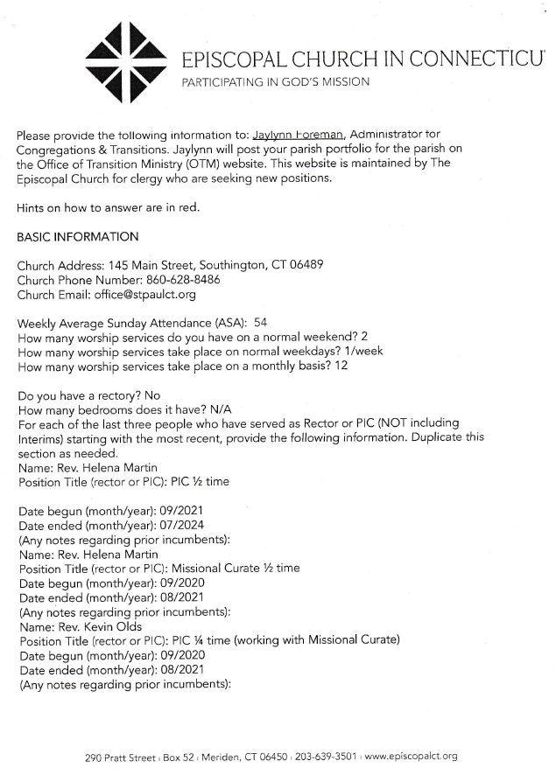

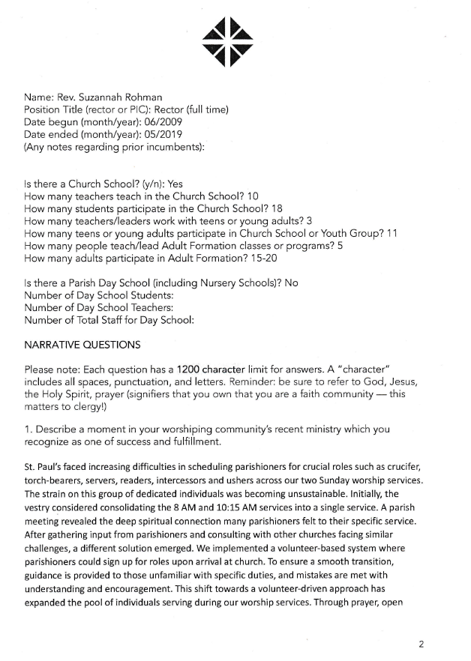

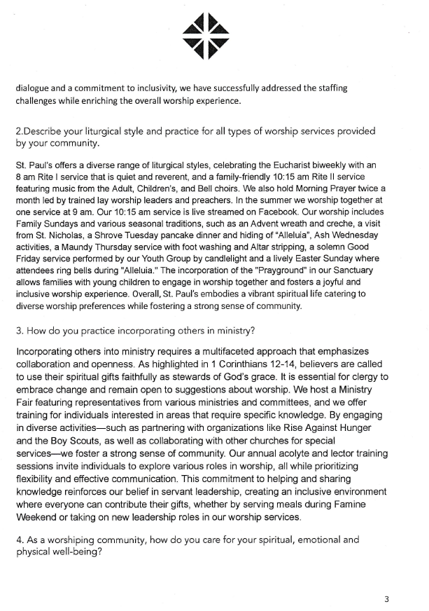

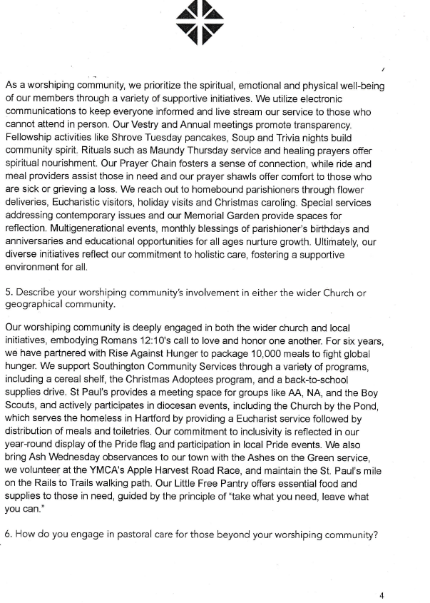

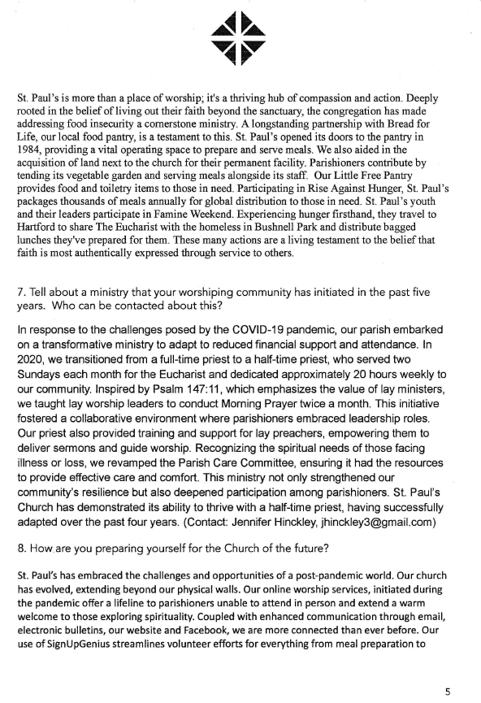

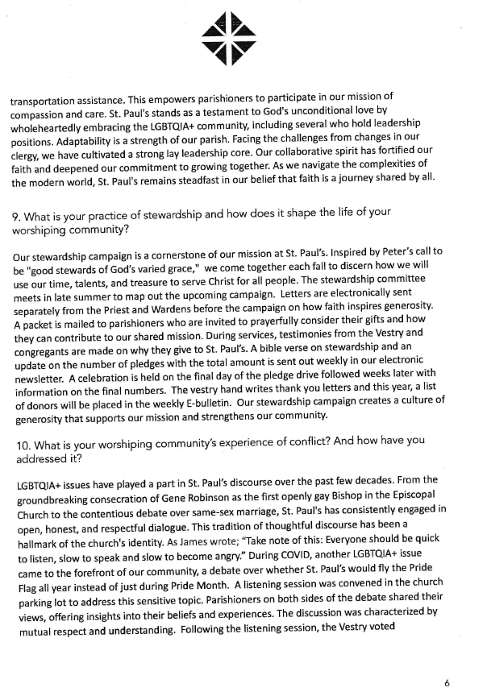



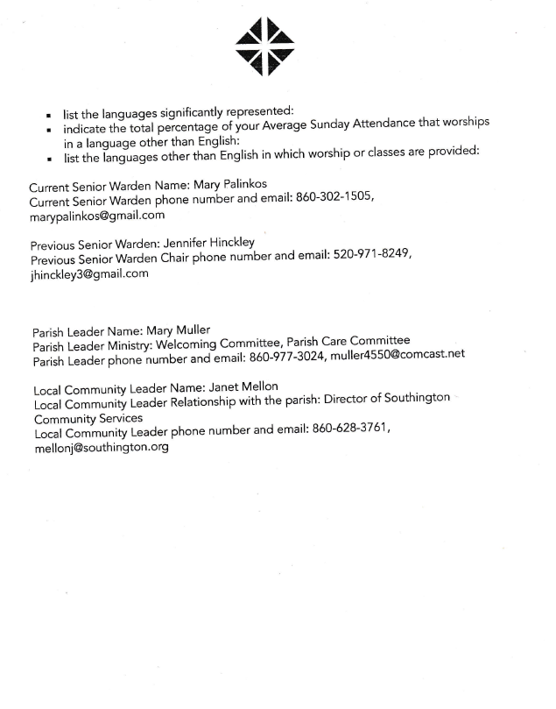

# Appendix C: Furnace Repair Proposals

